

毕业设计（论文）
外文文献翻译

专业 | 计算机科学与技术
学生姓名 | 戴鑫
班级 | U计算机131
学号 | 1330105126
指导教师 | 夏志杰

外文资料名称：Automated Discovery of JavaScript
Code Injection Attacks in PHP Web
Applications
外文资料出处：爱思唯尔期刊
附 件： 1.外文资料翻译译文
2.外文原文

指导教师评语：

签名：
年 月 日

PHP Web应用程序中JavaScript代码注入攻击的自动发现机制
鲁汶天主教大学,约翰内斯堡大学
戴鑫译
摘要:本文讨论了JavaScript注入攻击(例如跨站脚本(XSS)攻击)的现有防御性解决方案中的一些性能问题。此外，基于一些有用的度量，已经对这样的现有的解决方案进行了高水平的比较。基于识别的性能问题，本文提出了一种自动检测系统，扫描网站许多可能位置的JavaScript注入漏洞。我们的检测系统首先扫描网站以发现注入位置。其次，它在这样的注入点注入恶意的XSS攻击矢量。最后，它将输入作为在第二步中利用的不同XSS攻击列表，并在易受攻击的Web应用程序中扫描这些攻击。我们的自动化系统的检测能力在真实世界的PHP Web应用程序中(即BlogIt)上评估，并且获得的结果是非常有希望的。
关键词:跨站脚本(XSS)攻击;JavaScript注入漏洞;XSS备忘单;PHP

1.介绍
在现如今的万维网(WWW)时代，因特网上的在线设施通过现代网络应用程序非常容易地被不同社区地每个人访问。此外，向用户提供动态内容的社交网站，在线购物网站，网上银行和其他广泛的现代Web应用的繁荣增加了生成HTML内容的需求。这些内容可能就是各种Web漏洞的原因，如跨站脚本攻击(XSS)，信息泄露等。通常80%的现代Web应用程序容易受到这些攻击。XSS攻击是最有害的并且广泛的安全问题影响Web应用程序。XSS的攻击的关键思想是窃取用户数据的敏感资源(如Cookie，信用卡号码，密码等)[2-4]。使用这些凭据，攻击者可以简单地劫持任何网站的会话或访问受害者的Web应用程序的敏感资源。各种恶意的HTML链接在现代Web应用程序的网页上以非常有吸引力的模式制作，使得想知道链接的用户可以简单地点击它，成为XSS攻击的受害者，并且与攻击者妥协其凭据
成功的XSS攻击不仅可能对用户而且对网站造成严重的安全违规[20]。如果应用程序不验证其输入，黑客可以插入恶意脚本并窃取cookie，劫持用户的账户，传输私人信息，导致拒绝服务攻击，操纵网络内容以及更多的恶意活动。XSS已经成为WWW上最严重的危险之一。XSS[1]在报道的漏洞列表中排名第一。在本文中我们提出了一个自动检测系统，扫描几个可能位置注入点的XSS漏洞。我们还评估了我们提出的系统对真实世界中的PHP Web应用程序即BlogIt[6]的检测能力。
我们工作的主要贡献如下：
- 最近关于JavaScript注入漏洞的现有防御技术的最新技术已经与关键目标进行了讨论，以确定其解决方案中的弱点和研究空白。
- 提出了一种自动检测系统，旨在发现Web应用程序中的注入点和可能的恶意JavaScript注入漏洞。
- 我们提出的系统的实现是在客户端JavaScript库上完成的，在Web浏览器上进行少量的修改。
- 我们的检测系统的评估已经在现实生活的PHP Web应用程序BlogIt的测试版本上执行了。
其余的文章结构如下：第二部分强调了现有的JavaScript代码注入漏洞的工作，它们的优势和性能问题。提出的自动检测框架在第三节中说明。我们的工作的实现和评估在第四节中突出显示。最后，我们的工作的结论以及进一步的范围在第五节中说明。

2.相关工作
在本节中，我们讨论了各种XSS攻击检测和缓解技术，以确定这些技术中的研究缺口。表1突出了在XSS漏洞的防御方法的现有技术的先进技术中遇到的优势和性能问题。
此外，表2提供了九个不同类别的表1中描述的相同的现有技术的比较：开发位置，发现站点，审查机制，持久性，非持久性，基于DOM的XSS攻击检测，客户端Web浏览器更改，服务器端修改和JavaScript代码修正。
表2中显示的统计数据清楚地表明，大多数这些技术不提供对持久性以及DOM注入XSS漏洞的保护。除此之外，这些方法需要在浏览器Web应用程序的服务器上进行大量可能的修改。虽然，这些现有的防御方法包括在Web应用程序的源代码中的高级杀毒技术，但是它们也遭受高运行时间开销和不可接受的错误否定率。
为了解决这些问题，我们设计了一个自动化框架，用于在经过测试的真实世界PHP Web应用程序套件上发现JavaScript代码注入攻击。此技术在JavaScript库中的客户端Web浏览器上实现，并且在对PHP Web应用程序BlogIt的测试期间遇到可接受的假否定率。下一节以精确的方式说明我们提出的设计的细节。
3.拟议工作
在本文中我们设计了一个自动化检测系统，扫描网站许多可能的位置的脚本注入漏洞，如XSS。我们开发了一个自动化框架，探讨PHP Web应用程序的测试版本中的脚本注入漏洞。该系统检查网站的目的是发现可利用的XSS漏洞。图1展示出了我们提出的自动化检测设计。它由三个主要代理：HTML爬虫，XSS攻击矢量注入器和脚本定位器。图2还解释了我们自动化检测系统执行步骤的顺序。
3.1 HTML爬虫
HTML爬虫是一种代理，它扫描网站以发现可以利用持续XSS攻击的注入位置。这个分析过程类似于HTML解析器和网络蜘蛛，因为它完全恢复来自它接近的网页的数据，并且它在它发现的超链接之后在网页上循环。然而，这个爬虫不同于通常的爬虫在两个方面：它只是将具有端点的超链接引用到扫描的网站，忽略所有外部链接，提取的信息是Web表单。
技术日期 | 优势 | 性能问题
Kirda et al.2006 [9] | Noxes支持这种XSS攻击的缓解实践，大大减少了连接警报提示的数量，并提供了针对XSS攻击的防御 | 此外，此工具的可靠性低，禁止包含良性HTML。
Balzarotti et al. 2008 [10] | 此技术使用自下而上的方法，并尝试重新创建Web应用程序使用的源代码，然后使用恶意输入值运行此重新创建的代码，以确定有缺陷的清理例程。 | 由于现代网络浏览器的不断更新的性质，确认净化例程的可靠性，对于无脚本的HTML自然是一个具有挑战性的问题。
Sun et al. 2009 [11] | 它是一种客户端技术，以Firefox插件的形式使用，用于发现XSS攻击向量的传播，而不对web浏览器体系结构进行任何修改。 | 无法检测持久性和DOM类别的XSS攻击。
Johns et al. 2008 [12] | 它具有通过计算HTTP请求之间的偏差以及其相关联的HTTP响应来发现XSS攻击的良好能力。 | 发现持续性XSS攻击的方法受到很少的误报，并且需要更高级的训练阶段来收集更多的脚本。
Bisht et al. 2008 [13] | 它的主要优点是它可以避免非法脚本数据成为HTTP响应网页的一部分。 | 虽然这种技术尝试净化不安全的输出，它仍然影响Web浏览器解析器推断不安全的数据以及易受威胁使用浏览器解析的扭曲。
Balzarotti et al. 2007 [14] | 它是一种漏洞调查技术，它识别由几个PHP模块影响的真实Web应用程序的非预期工作流程。此外，监视代码流执行以确定程序的预期工作流是否可以被污染或不修改诸如cookie，会话id等的敏感信息。 | 然而，这种技术需要用于仪器的web应用的源代码，其在实践中可能是不可访问的。此外，该技术具有假否定。
Jovanovic et al. 2006 [15] | Pixy是第一个开源静态分析工具，旨在通过数据流分析的帮助发现PHP脚本中的XSS漏洞。作者利用过程和上下文敏感的方法来识别PHP 4程序源代码中的弱点。 | 这个静态分析工具不能处理PHP编程语言的动态特性，如加密数据和混淆代码。此外，该静态分析方案不呈现任何可执行的测试用例。
Nadji et al. 2009 [16] | 这种技术提供了保证动态用户生成的数据从服务器上的固定数据隔离，虽然在浏览器相互联合，以更好的防御XSS攻击以完整性保护的方式。 | 提出这种技术以便于用户注入的内容在web浏览器上安全地解释，但是不能保证防止对web浏览器的XSS攻击。
Futoransky et al. 2007  [17] | 这种技术提供了一个改进得很好的PHP解释器，GRASP，它提供了一个准确的动态污点检查PHP，以及允许预防措施指南被污染的JavaScript字符串。 | 虽然它实现了字符级别的污点跟踪，但它实现了40-100％的开销。
Jim et al. 2007 [18] | BEEP结合了所有网页的受信任脚本的白名单，以及灌输修改的浏览器以清除不可信的脚本。 | 此技术具有可扩展性问题，因为每个用户都需要此特定浏览器的副本。
表1 XSS攻击相关现有技术的总结

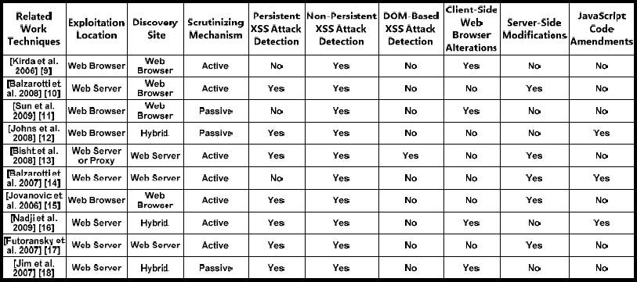
表2 比较现有的防御性解决方案对基于良好定义参数的XSS攻击

3.2 XSS攻击矢量注入器
这个注入器利用通过HTML爬虫代理检索并保存在web表单数据库中的web表单池。该代理将从知名数据库[5]中插入一系列恶意XSS脚本到注入点的每个位置的各种不同输入字段中。用于评估我们提出的方法的XSS攻击的不同类别通过恶意XSS攻击向量的存储库检索[5]。这些恶意的XSS攻击向量使用各种各样的注入随机脚本的方法，这些方法被web应用忽视，在我们的情况下; 它作为真正的数据包含在Web应用程序中。
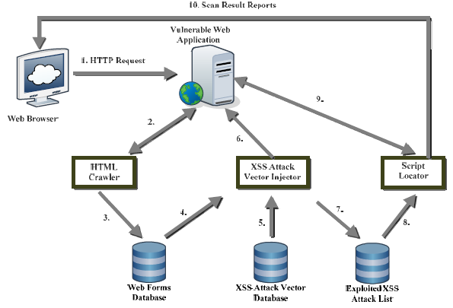
图1 自动检测系统的设计

算法：自动检测系统
1. 通过利用HTML爬虫的功能，在Web应用程序（WA）中发现注入点IPi（i = 1,2,3，... n）的可能位置。
2. 提取来自WA的Forms Fi（对于i = 1，2，3，---- n）的集合，这些集合被认为是XSS攻击的可能目标。
3. 经由XSS攻击矢量注入器将XSS攻击矢量Xj（用于j = 1,2,3，...，n）注入到每个的不同输入字段IFk（用于k = 1,2,3，... n）的IPi的可能位置。
4. 最后，脚本定位器代理将输入作为XSS攻击向量注入器利用的不同XSS攻击的列表，并在WA中扫描这些攻击。
图2 自动化检测系统算法
3.3 脚本定位器
脚本定位器将经过XSS攻击向量代理先前生成的利用XSS攻击列表作为输入，并在所检查的Web应用程序中搜索那些XSS攻击。寻找恶意插入的脚本是至关重要的，因为持久XSS攻击的实现无法在回答包含恶意XSS攻击向量的HTTP请求时立即确认。因此，可以想到发现web应用是否指示在整个扫描周期中识别的任何持久XSS漏洞。在通过改进导致实现这种攻击的输入验证失误来保护web应用的过程中，在web应用的第二阶段扫描中获得的结果是非常有价值的。
4.实施和实验结果
我们已经在一个真实世界的PHP Web应用程序（即BlogIt）上测试了我们提出的自动检测系统。BloggIt [6]是可以免费访问的博客网络应用平台，帮助用户管理博客，发送邮件和发表评论。此Web应用程序允许非法用户访问敏感的管理功能。BlogIt Web应用程序和我们的检测系统安装在运行Windows 7，Apache Tomcat服务器（版本2.2.8）和PHP（版本5.5.14）的1.63GHz双核Linux服务器上。我们已经收集我们的数据集作为恶意XSS攻击向量从XSS工作表[5]。这些攻击矢量在BlogIt PHP Web应用程序上被利用。表3显示了BlogIt PHP Web应用程序上观察到的一些统计结果。
XSS攻击的类别 | XSS攻击矢量注入 | 检测到XSS攻击向量 | 假阴性 | 检测率
事件处理程序 | 30 | 21 | 9 | 70.00%
字符编码攻击 | 30 | 20 | 10 | 66.66%
基本的XSS攻击 | 30 | 24 | 6 | 80.00%
HTML元素攻击 | 35 | 31 | 4 | 88.57%
其他攻击 | 28 | 14 | 14 | 50.00%
表3 BlogIt Web应用程序的观察结果

5. 结论和未来工作
XSS漏洞通常被用来通过在Web应用程序的可能注入点中插入函数调用来执行恶作剧行为。同样，当前服务器端XSS漏洞检测方法需要在浏览器和服务器端设置的变化，以及从服务器到浏览器的易受攻击数据的传输。在本文中，我们提出了一个自动检测系统，扫描可能的注入位置为XSS漏洞。评估结果表明，我们的系统发现BlogIt PHP Web应用程序上的XSS漏洞具有可接受的运行时开销。
作为进一步工作的一部分，我们将尝试提高我们的方法的假阴性率。除此之外，我们还将预期一些检测基于DOM的XSS漏洞的机制。最后，我们希望传播我们提出的框架的使用，以发现其他漏洞，如网络钓鱼，ClickJacking攻击等。我们还计划评估我们的检测系统对更多的Web应用程序的发现能力作为我们进一步工作的一部分。

外文原文
Automated Discovery of JavaScript Code Injection Attacks in PHP Web Applications
Shashank Guptaa , B. B. Guptab*
Abstract: This paper discussed some of the performance issues in the existing defensive solutions of Java Script injection attacks(e.g.Cross-SiteScripting (XSS) attacks). Moreover, a high level of comparison for such existing solutions has been done based on some useful metrics. Based on the identified performance issues, this paper proposed an automated detection system, which scans the numerous possible locations of web sites for JavaScript injection vulnerabilities. Our detection system, firstly, scans the web site for discovering the injection locations. Secondly, it injects the malicious XSS attack vectors in such injection points. Lastly,it takes an input as the list of different XSS attacks exploited in the second step and scan for these attacks in the vulnerable web application. Detection capability of our automated system is evaluated on a real world PHP web application i.e. BlogIt and results obtained are very promising.
Keywords: Cross-Site Scripting (XSS) attacks; JavaScript Injection Vulnerabilities; XSS Cheat Sheet;PHP

1. Introduction
In the contemporary era of World Wide Web (WWW), online facilities on the Internet are easily accessible by the modern web applications by every single human of different community. Moreover, boom of social networking sites, online shopping sites, Internet banking and all other widespread modern web applications, which provides the dynamic content to the users have increased the demand of user generated HTML content. This content can be the reason for various web vulnerabilities like Cross-Site Scripting (XSS) attacks [19], Information leakage etc. Normally 80% of modern web applications are vulnerable to these attacks. XSS attack is the utmost harmful and widespread security issue affecting web applications. The key motto of XSS attacks is to theft the sensitive resources of user data (like cookies, credit card numbers, passwords etc.) [2-4]. Using these credentials, an attacker can simply hijack the session of any web site or access the sensitive resources of victim’s web application. Various malicious HTML links are crafted in a very appealing mode on the web pages of modern web applications so that users curious to know about the link can simply click on it, become a victim of XSS attack and compromise its credentials with the attacker.
A successful XSS attack can result in stern security violations for not only the user but also for the web site [20]. If an application doesn’t validate its input, a hacker can insert a malicious script and steal cookies, hijack a user’s account, transfer private information, cause denial of service attack, manipulate the web content, and many more malicious activities. XSS has appeared as one of the utmost severe dangers on the WWW. XSS falls first in the list of vulnerabilities reported published in [1]. In this paper, we have proposed an automated detection system, which scans several possible locations of injection points for the XSS vulnerabilities. We have also evaluated the detection capability of our proposed system on real world PHP web application i.e. BlogIT [6]. The main contributions of our work are as follows:
􀁸 • Recent existing defensive state-of-art techniques on JavaScript injection vulnerabilities have been discussed with
the key goal to identify the weaknesses and research gaps in their solutions.
􀁸• An automated detection system is proposed with the aim to discover injection points in a web application and
possible malicious JavaScript injection vulnerabilities.
􀁸• Implementation of our proposed system was done on a client-side JavaScript library with few modifications on
the web browser.
􀁸• Evaluation of our detection system has performed on a tested version of real life PHP web application BlogIT.
Rest of our article is structured as follows: Section 2 highlights the existing work on JavaScript code injection vulnerabilities in the form of their strengths and performance issues. The proposed automated detection framework is illustrated in Section 3. Implementation and evaluation of our work is highlighted in Section 4. Finally, conclusion as well as further scope of our work is illustrated in Section 5.

2. Related Work
In this section, we have discussed various XSS attacks detection and mitigation techniques in order to identify the research gaps in such techniques. Table 1 highlights the strengths and performance issues encountered in the existing state-of-art techniques of defensive methodologies of XSS vulnerabilities.
In addition, Table 2 provides a comparison of same state-of-art techniques described in Table 1 based on nine different categories: Exploitation Location, Discovery Site, Scrutinizing Mechanism, Persistent, Non-Persistent, DOM-Based XSS attack detection, Client-side web browser alterations, Server-side modifications and JavaScript Code Amendments. The statistics shown in the Table 2 clearly highlights that most of these techniques does not provide the protection against persistent as well as DOM injection XSS vulnerabilities. In addition to this, these methodologies need large-possible amendments at browser and web application’s server. Although, these existing defensive methodologies included the advanced techniques of sanitization in the source code of web applications, however that too suffer from high runtime overhead and non-acceptable rate of false negatives.
To address such issues, we designed an automated framework for the discovery of JavaScript code injection attacks on a tested suite of real world PHP web applications. This technique is implemented on a client-side web browser in JavaScript library and encounters acceptable rate of false negatives during its testing on PHP web application BlogIT. The next section illustrates the details of our proposed design in a precise manner.

3. Proposed Work
In this paper, we have designed an automated detection system, which scans the numerous possible locations of web sites for script injection vulnerabilities like XSS. We developed an automated framework that explores for the script injection vulnerabilities in the tested version of PHP web applications. This system examines the web sites with the goal of discovering exploitable XSS vulnerabilities. Fig. 1 illustrates the design of our proposed automated detection system. It consists of three key agents: HTML Crawler, XSS Attack Vector Injector and Script Locator. Fig. 2 also explains the sequence of steps of execution of our automated detection system.

3.1 HTML Crawler
HTML crawler is an agent which scans the web site for discovering the injection locations where Persistent XSS attacks can be exploited. This analyzing procedure is analogous to that of HTML parsers and web spiders, since it thoroughly recovers data from the web pages it approaches and it circulates over the web site following the hyperlinks it discovers. However, this crawler varies from the usual crawler in two facets: It simply refers the hyper-links with endpoint to the scanned web site neglecting all exterior links and, the info extracted is web forms.
Table 1. Summary of Related Existing Techniques on XSS Attacks
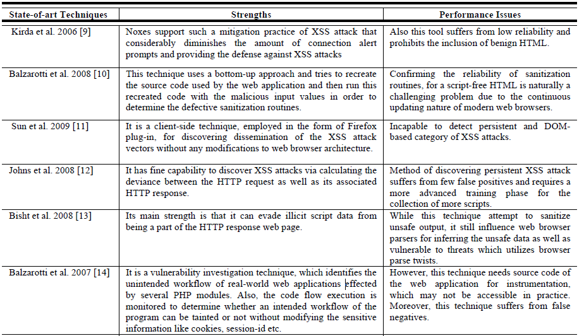
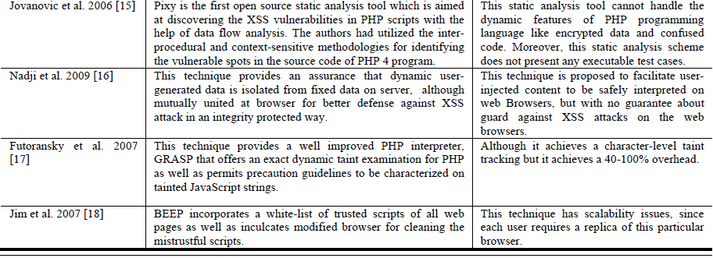
Table. 2. Comparison of Existing Defensive Solutions on XSS Attacks Based on Well-Defined Parameters
3.2 XSS Attack Vector Injector
This injector utilizes the pool of web forms retrieved through the HTML crawler agent and saved in the web form database. This agent will insert a collection of malicious XSS scripts from a well-known database [5] into the wide variety of different input fields of each location of injection points. The different category of XSS attacks utilized for the assessment of our proposed methodology was retrieved via a repository of malicious XSS attack vectors in [5]. Those malicious XSS attack vectors make usage of wide variety of methods of injecting random script which is disregarded by the web application and, in our situation; it is included as genuine data in the web application. Fig. 1.
Fig. 1. Proposed Design of Automated Detection System
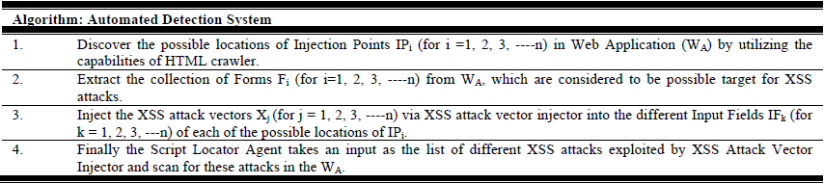
Fig. 2. Algorithm of Automated Detection System
3.3 Script Locator
The script locator takes as input the list of exploited XSS attacks, which was previously generated via the XSS attack vector agent, and searches for those XSS attacks in the examined web application. It is essential to look for the malicious inserted scripts as the realization of Persistent XSS attacks cannot be confirmed instantaneously in the reply to the HTTP request which enclosed the malicious XSS attack vector. Therefore, it is conceivable to discover if the web application indicates any of the Persistent XSS vulnerabilities recognized throughout the scanning period. The outcomes achieved in this second phase of scanning of web application are very valuable in the procedure of safeguarding the web application by improving the input validation blunders which led to the realization of such attacks.

4. Implementation and Experimental Results
We have tested our proposed automated detection system on one real-world PHP web application i.e. BlogIt.BloggIt [6] is freely accessible web application platform of blogs that assist users for managing a blog, send mails and post the comments. This web application permits illegitimate users to gain access to sensitive administrative functionality. BlogIt web application and our detection system are installed on a 1.63GHz Dual Core Linux server with 2GB RAM, running Windows 7, Apache Tomcat server (version 2.2.8) and PHP (version 5.5.14). We have collected our datasets as malicious XSS attack vectors from the XSS Cheat Sheet [5]. These attack vectors are exploited on the BlogIt PHP web application. Table 3 shows some of the statistics of observed results on BlogIt PHP web application.
Table 3. Observed Results of BlogIt Web Application
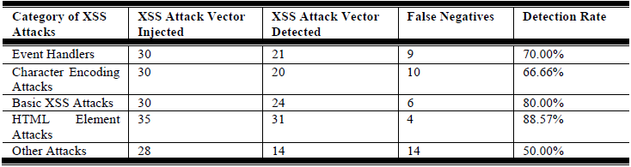

5. Conclusion and Future Work
XSS vulnerabilities are usually exploited to execute mischievous actions by inserting function calls in the possible injection points of web application. Likewise,the current server side XSS vulnerability detection methodologies require variations at both browser and server-side settings as well as transmission of vulnerable data from server to browser. In this paper, we have proposed an automated detection system, which scans the possible injection locations for the XSS vulnerabilities. The evaluation results showed that our system discovers the XSS vulnerabilities on the BlogIt PHP web application with acceptable runtime overhead.
As a part of further work, we will try to improve the false negative rate our approach. In addition to this, we will also anticipate some mechanism of detecting DOM-based XSS vulnerabilities. Lastly, we wish to spread the utilization of our proposed framework for discovering other vulnerabilities like Phishing, ClickJacking attacks, etc. We will also plan to assess the discovery ability of our detection system on more web applications as a part of our further work.

References
1. Symantec internet security threat report 2009. Retrieved from: http://www.symantec.com/business/threatreport/.
2. Shashank Gupta, B.B. Gupta.PHP-Sensor: A Prototype Method to Discover Workflow Violation and XSS Vulnerabilities in PHP web
applications.in 12th ACM International Conference on Computing Frontiers (CF ’15), Ischia, Italy;2015.
3. Shashank Gupta, Lalitsen Sharma et al.Prevention of cross-site scripting vulnerabilities using dynamic hash generation technique on the
server side.International journal of advanced computer research (IJACR);2012, 49-54.
4. Shashank Gupta, Lalitsen Sharma.Exploitation of Cross-site Scripting (XSS) vulnerability on Real World Web Applications and its
Defense.International journal of computer applications (IJCA), pp. 28-33;2012.
5. Rsnake. XSS Cheat Sheet, 2008. Retrieved from. https://www.owasp.org/index.php/XSS_Filter_Evasion_Cheat_Sheet
6. PHP-blogit: Retrieved from: http:sourceforge.net/projects/php-blogit/
7. Shashank Gupta, B.B. Gupta.BDS: Browser Dependent XSS Sanitizer Book on Cloud-Based Databases with Biometric Applications.IGIGlobal’s
Advances in Information Security, Privacy, and Ethics (AISPE) series, pp. 174-191, USA;2014.
8. B.B.Gupta, Shashank Gupta, S.Gangwar, M.Kumar, P.K. Meena.Cross-Site Scripting (XSS) Abuse and Defense: Exploitation on Several
Testing Bed Environments and its Defense.Special Issue of Secured Communication in Wireless and Wired Networks in Journal of
Information Privacy and Security, Taylor & Francis Online, Vol. 11, Issue 2, pp. 118-136;2015.
9. Engin Kirda, Christopher Kruegel, Giovanni Vigna, and Nenad Jovanovic.Noxes: A client-side solution for mitigating cross-site scripting
attacks.In SAC’06: Proceedings of the 2006 ACM Symposium on Applied Computing, pp. 330–337;2006.
10. Balzarotti, Davide, Marco Cova, Vika Felmetsger, Nenad Jovanovic, Engin Kirda, Christopher Kruegel, and Giovanni Vigna.Saner:
Composing static and dynamic analysis to validate sanitization in web applications. In Security and Privacy, 2008. SP 2008. IEEE
Symposium on, pp. 387-401. IEEE;2008.
11. SUN, F., XU, L., AND SU, Z. Client-side detection of XSS worms by monitoring payload propagation. In ESORICS, M. Backes and P.
Ning, Eds., vol. 5789 of Lecture Notes in Computer Science, Springer, pp. 539–554;2009.
12. M. Johns, B. Engelmann, and J. Posegga. XSSDS: Server-side Detection of Cross-site Scripting Attacks. In Annual Computer Security
Applications Conference (ACSAC), 2008.
13. P. Bisht and V. N. Venkatakrishnan. XSS-GUARD: precise dynamic prevention of cross-site scripting attacks. In Detection of Intrusions
and Malware, and Vulnerability Assessment, 2008.
14. Balzarotti, Davide, Marco Cova, Viktoria V. Felmetsger, and Giovanni Vigna.Multi-module vulnerability analysis of web-based
applications.In Proceedings of the 14th ACM conference on Computer and communications security, pp. 25-35. ACM, 2007.
15. Jovanovic, Nenad, Christopher Kruegel, and Engin Kirda.Pixy: A static analysis tool for detecting web application vulnerabilities.In
Security and Privacy, 2006 IEEE Symposium on, pp. 6-pp. IEEE;2006.
16. Nadji, Yacin, Prateek Saxena, and Dawn Song.Document Structure Integrity: A Robust Basis for Cross-site Scripting Defense.In NDSS.
;2009

